MoviesDen Cinema

**User Guide**

**GROUP MEMBERS:**

|  |  |
| --- | --- |
| **Students1681274** | **Ubaid Ur Rehman** |
| **Students1683239** | **MUHAMMAD Taha Ahmed** |
| **Students1683211** | **SYEDA mahek fatima** |
| **Students1681267** | Usman Khan |
| **Students1683214** | **Hafiz syed fareed ul hassan** |

**CURRICULUM:** **ACCP AI**

**SEMESTER:** **CPISM**

**FACULTY:** Miss maryam masood

**CERTIFICATE OF RECOGNITION:**

This is to certify that **[Ubaid Ur Rehman, Taha AHmed, Usman Khan, Mahek Fatima, Syed hassan ul fareed]** has successfully completed the project titled **“MoviesDen – Online Cinema Ticket Booking Website”** as part of the academic requirements.

The project demonstrates outstanding creativity and technical expertise in developing a modern, user-friendly cinema website. It includes features such as movie listings, showtime schedules, online ticket booking, seat selection, genre-based categorization, trailers, upcoming movie updates, and a dedicated section for featured films. The design ensures visual consistency, smooth navigation, and an engaging user experience throughout the platform.

This certificate is awarded in recognition of the students’ dedication, innovative approach, and commitment to achieving professional standards in web development.

**Presented On:** Dec **10,2025**

**Authorized Personality: Miss Maryam Masood**

**ACKNOWLEDGEMENT:**

I would like to express my sincere gratitude to my project guide and all those who supported me throughout the completion of my project titled **“MoviesDen – Online Cinema Ticket Booking Website.”** Their valuable guidance, constant encouragement, and constructive suggestions played a crucial role in helping me design and develop this project successfully.

I am also thankful to my teacher **[Miss Maryam]** and my institution for providing me with the necessary resources, technical support, and a motivating environment that enabled me to enhance my skills in web development.

Finally, I extend my heartfelt thanks to my friends and family for their continuous motivation, understanding, and support. Their belief in me made this project possible.

**SYNOPSIS:**

The project **“MoviesDen – Online Cinema Ticket Booking Website”** aims to create a modern, user-friendly platform for browsing movies and booking cinema tickets with ease. The website features categorized movie listings based on genres, languages, and popularity, ensuring smooth navigation and an engaging visual experience. It includes essential sections such as **Home, Now Showing, Upcoming Movies, Showtimes, Ticket Booking, About Us, and Contact Us with map integration**.

The platform provides updated movie details, trailers, seat selection options, and a streamlined booking process. Optimized images and proper alt attributes enhance accessibility, performance, and overall user experience.

Overall, the project reflects creativity and technical proficiency in developing an interactive and efficient online cinema ticket booking system.

**Categories:**

The website **“MoviesDen – Online Cinema Ticket Booking Website”** offers a wide range of categories to help users browse and book movies with ease. The movies are organized by **genre**, including popular categories such as **Action, Comedy, Drama, Horror, Thriller, Romance, Sci-Fi, and Animation**. They are also categorized by **language**, such as **English, Hindi, Urdu, Tamil, Telugu, Punjabi, and Malayalam**, allowing users to quickly find content that matches their preferences.

Further classification is provided based on **movie format**, including **2D, 3D, IMAX, and 4DX**, enhancing the cinema experience for users. The platform also features categories like **Now Showing, Coming Soon, Top Rated, Trending Movies, and Family Favorites**.

In addition to movies, the website offers essential cinema-related options such as **showtime schedules, seat selection, multiple theatre choices, and ticket pricing**. Users can also explore exclusive sections like **trailers, cast details, movie summaries, and user reviews**, ensuring a complete and engaging movie-browsing experience.

Popular cinemas and entertainment brands such as **Cinepax, Nueplex, Universal Cinemas, and Sozo Cinemas** are featured, providing users with a diverse and premium ticket-booking experience.

**Distribution:**

You can find the location of our cinema in a very convenient way through the website. You can also view the experiences and reviews shared by our previous visitors, along with the services we provide to ensure a smooth and reliable ticket-booking experience.

**PROBLEM STATEMENT:**

**MoviesDen** is one of the leading online platforms for browsing movies and booking cinema tickets. The website is connected with various popular cinemas and theatres, whose latest movie listings and showtimes are displayed for users. It also provides detailed information on movies, including genres, cast, trailers, and user ratings, along with options such as seat selection and multiple show timings.

A dedicated website needs to be developed for MoviesDen that showcases all available and upcoming movies, cinema locations, and booking features. The website must provide a smooth and user-friendly experience for users to explore movies, check schedules, and book tickets conveniently.

**Requirement Specification:**

The Web size is so be creased based on she following requirements.

## ****1. Home Page****

The homepage must have a visually appealing and consistent color scheme.

All required navigation links should be clearly defined.

The layout should be fully utilized to avoid unnecessary blank spaces.

## ****2. Content Sections****

The website must include detailed information about:

**Urdu Theatre Shows**

**Hindi Theatre Shows**

**English Theatre Shows**

**Auditoriums**

**Theatre Speak (Reviews & Discussions)**

**Artist Gallery**

**Upcoming Shows**

**Venue details** of current and upcoming shows

## ****3. Awards Section****

The website should include details of awards related to theatre and artists.

## ****4. Navigation****

The navigation throughout the website must be smooth, user-friendly, and consistent on every page.

## ****5. Theatre Speak****

This section should include detailed reviews, comments, and discussions about theatre shows.

## ****6. Auditoriums****

The website must display a list of auditoriums where theatre events are held.

## ****7. Upcoming Events****

A proper list of upcoming theatre events must be included and regularly updated.

## ****8. Magazines****

Theatre-related magazines and publications should be included in this section.

## ****9. Design Uniformity****

A consistent design theme, colors, and styling should be maintained across all pages.

## ****10. Artist Gallery****

The website must contain an artist gallery with images and details of theatre artists.

## ****11. Feedback Section****

A feedback form or section should be available for users to submit their opinions.

## ****12. Queries Section****

A query submission section may be included for users to ask questions or request information.

**Guide:**

**NAVBAR(ALLsPAGES):**

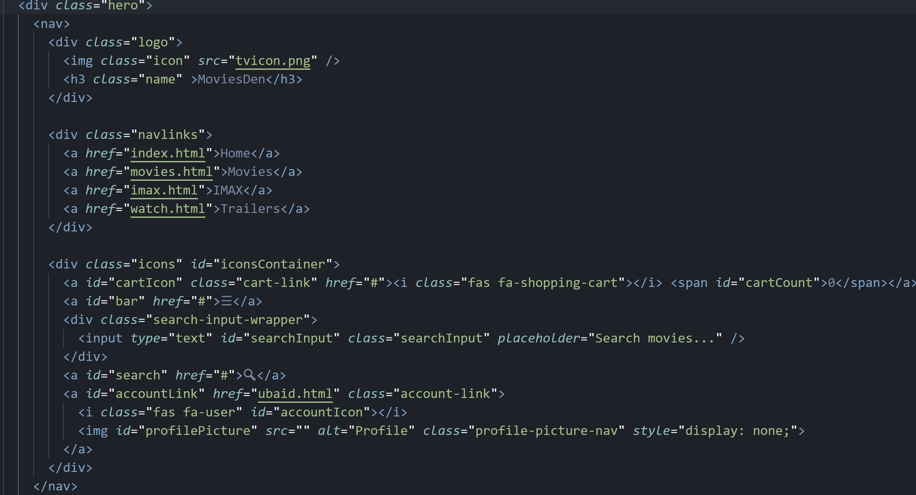

**NAVBAR(NavbarToggleFunctionality):**

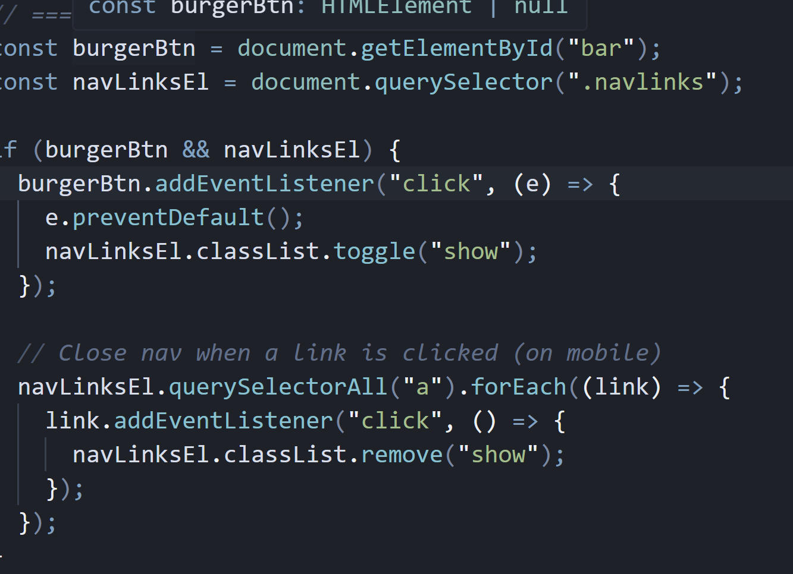

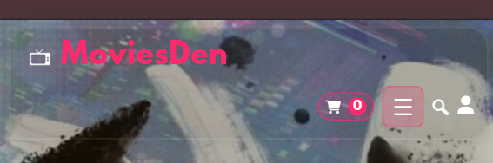

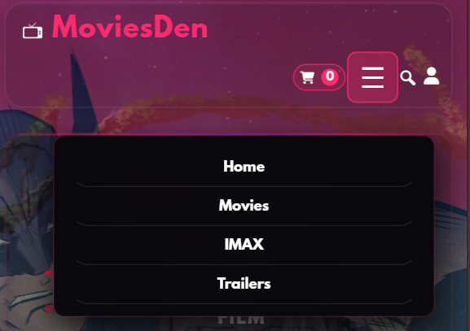

**Hero(index.HTML):**

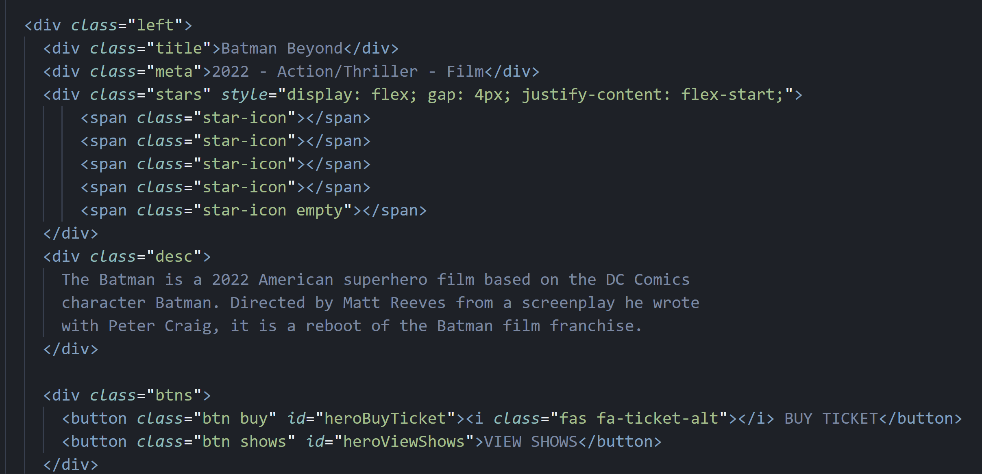

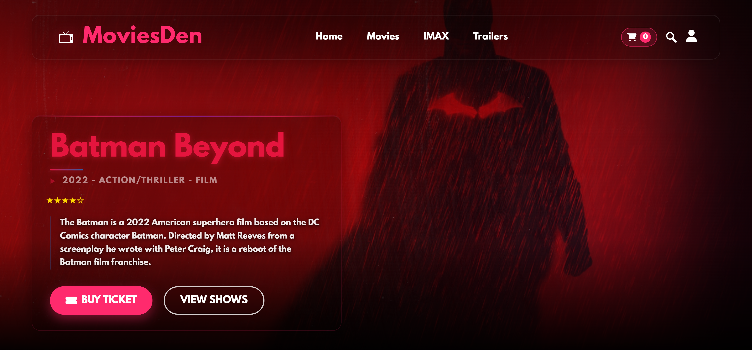

**movies(Movies.HTML):**

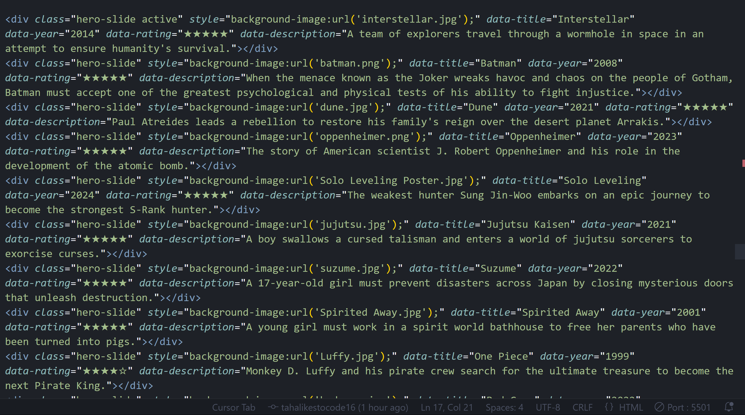

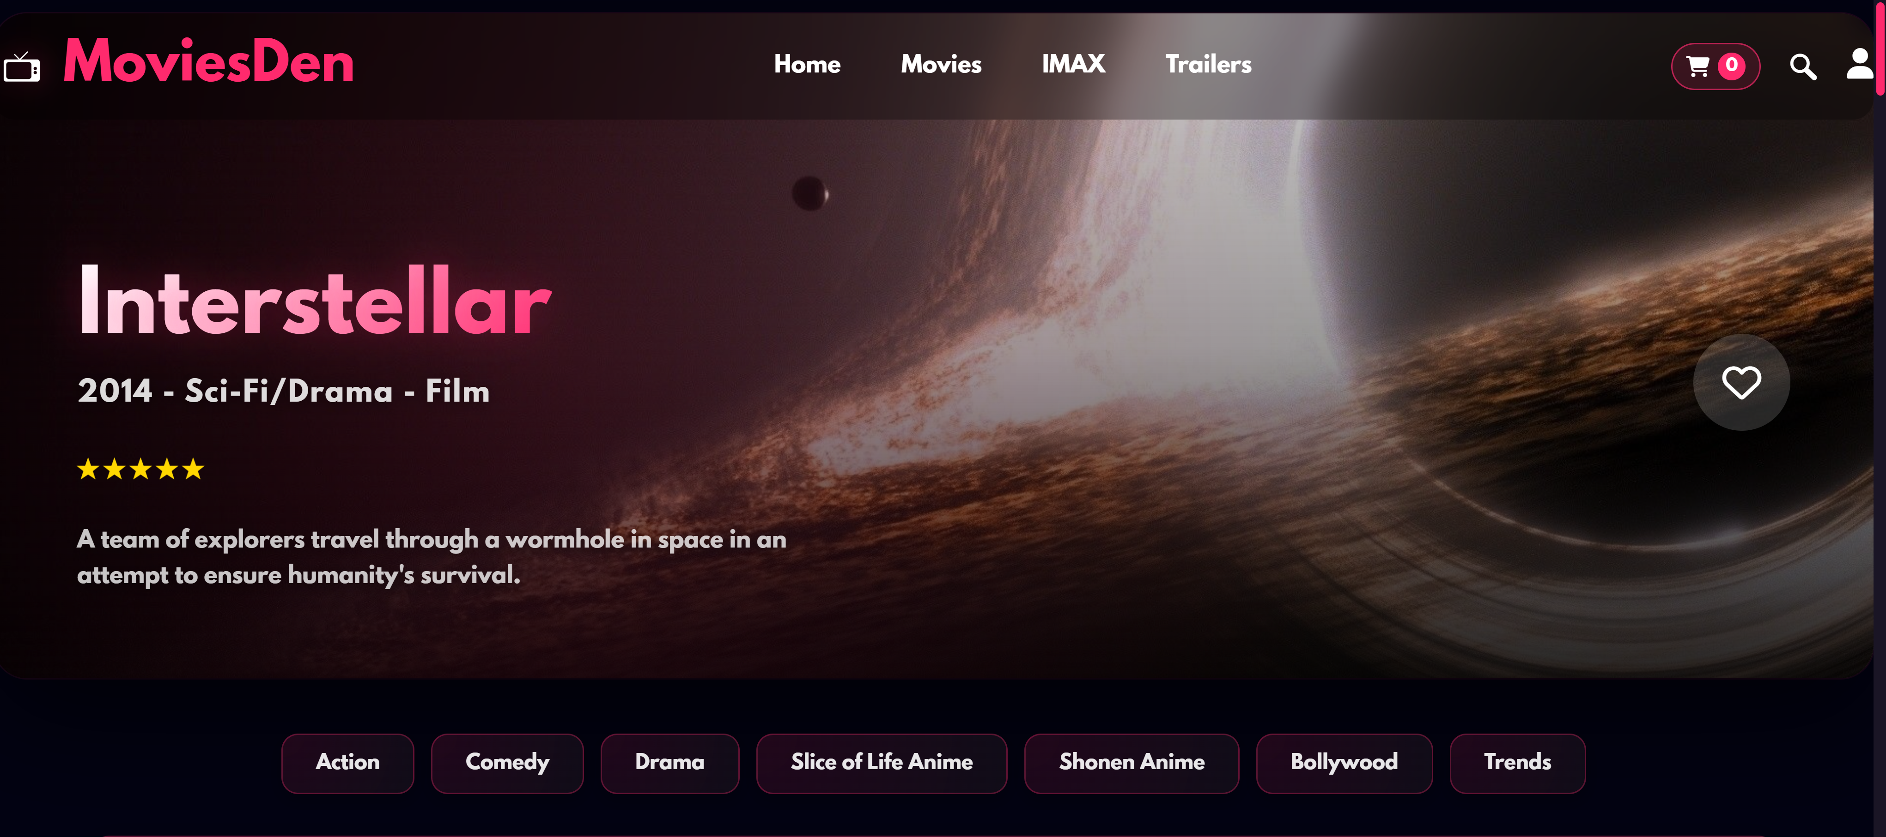

**imax(imax.HTML):**

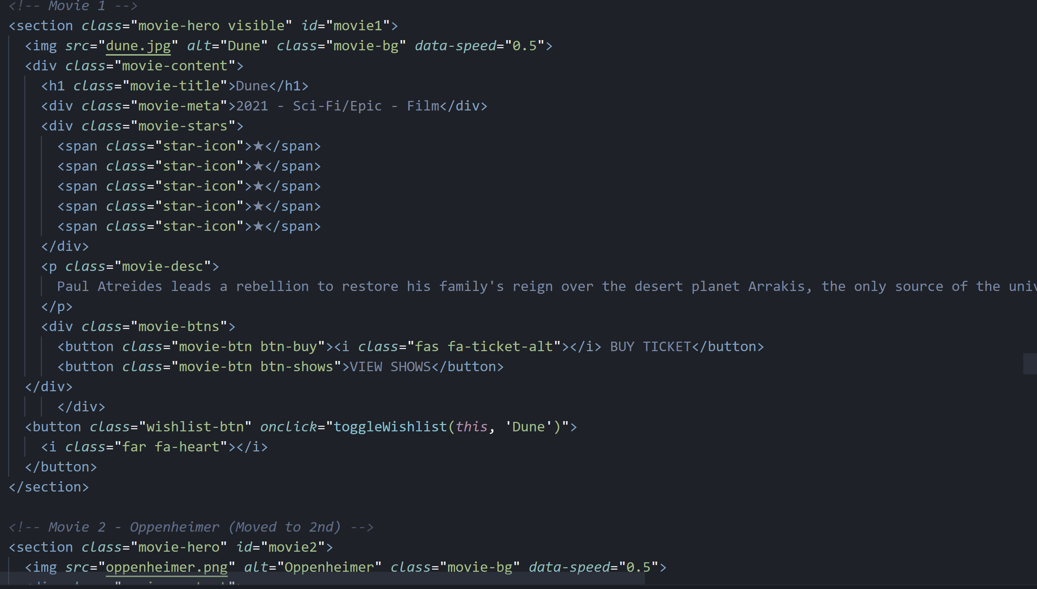

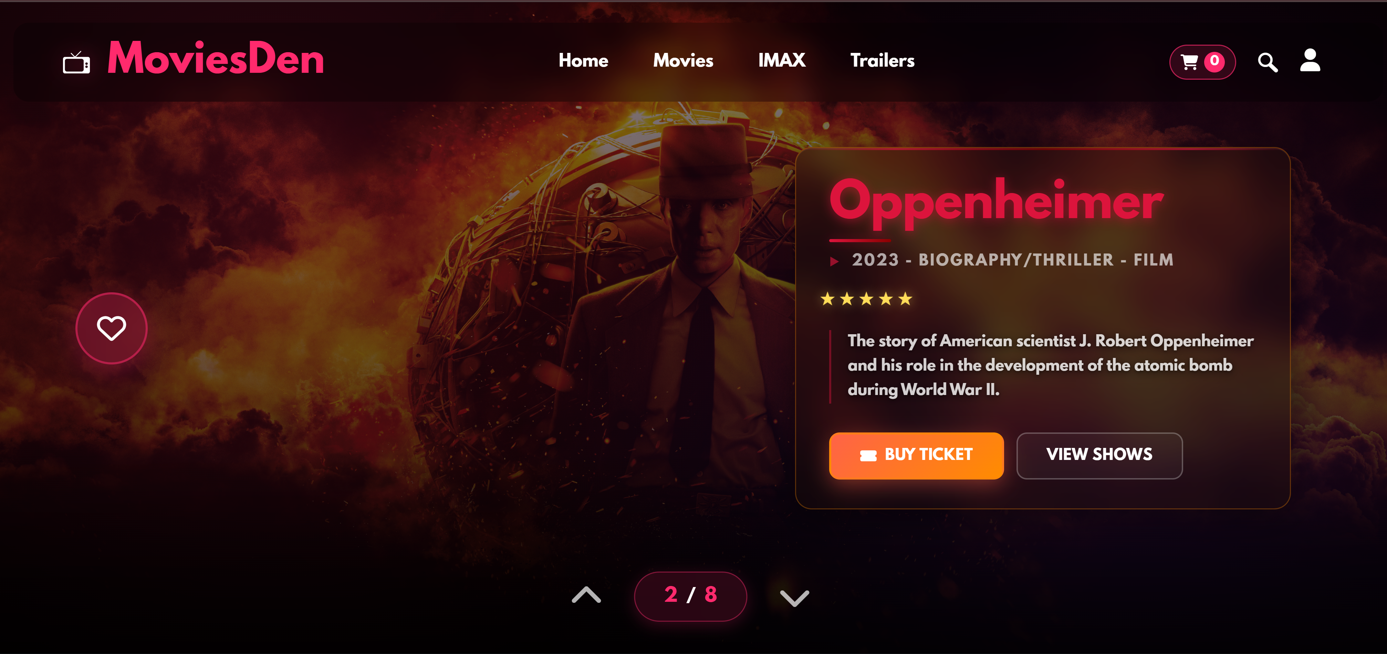

**Gallery(Gallery.HTML):**

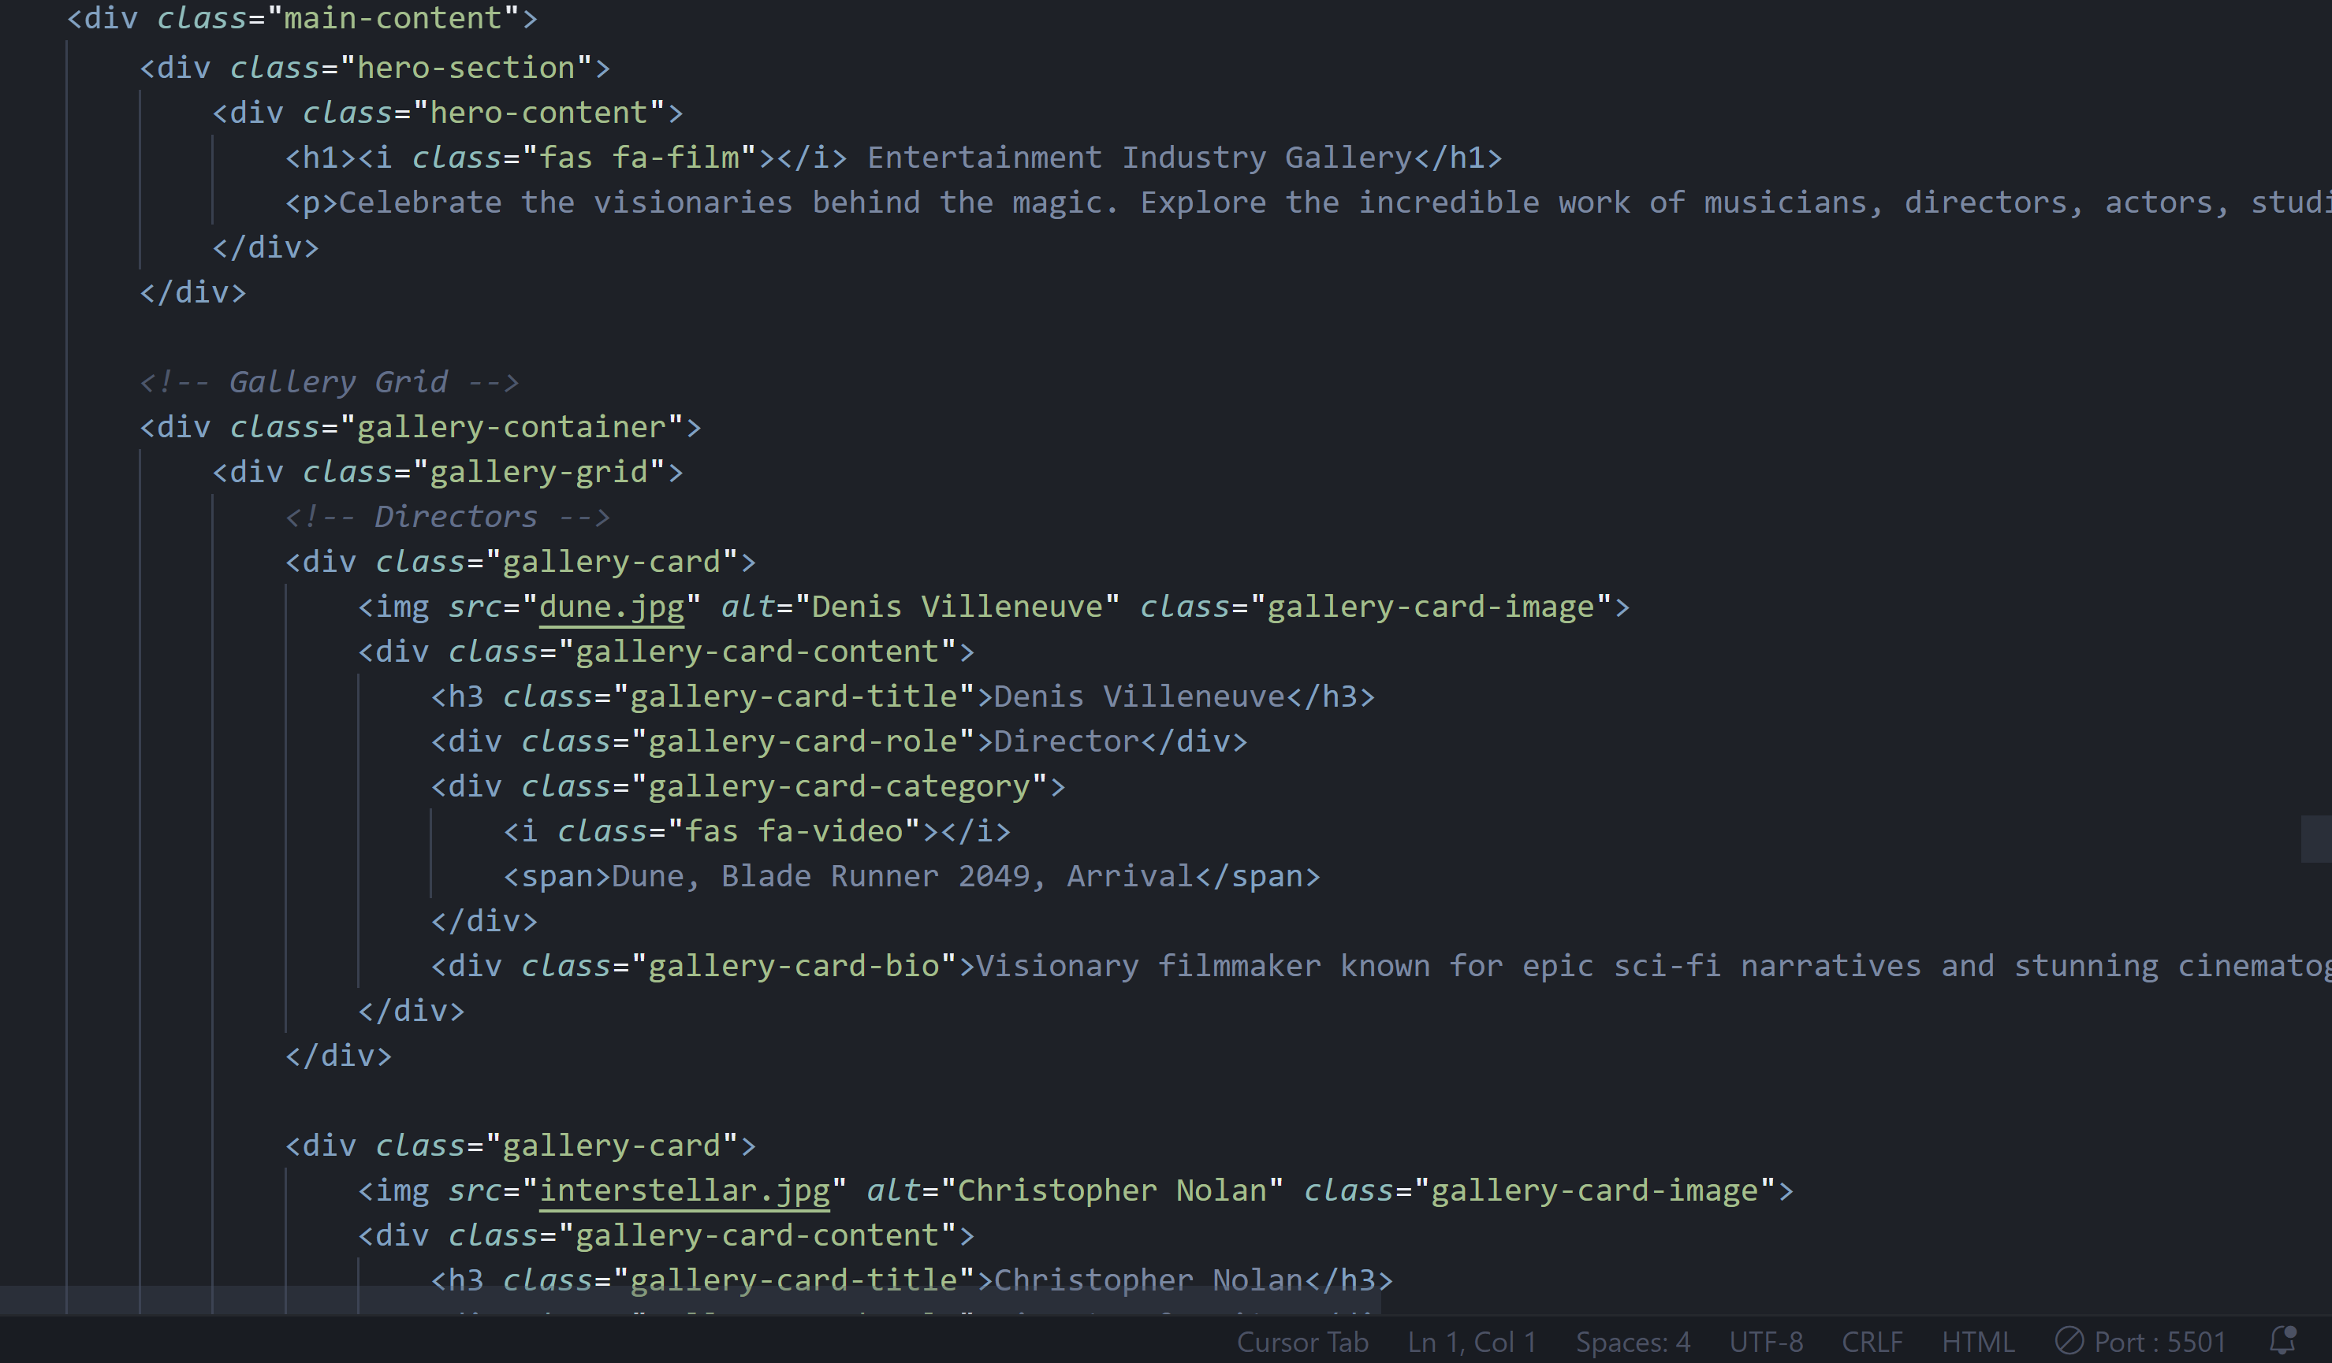

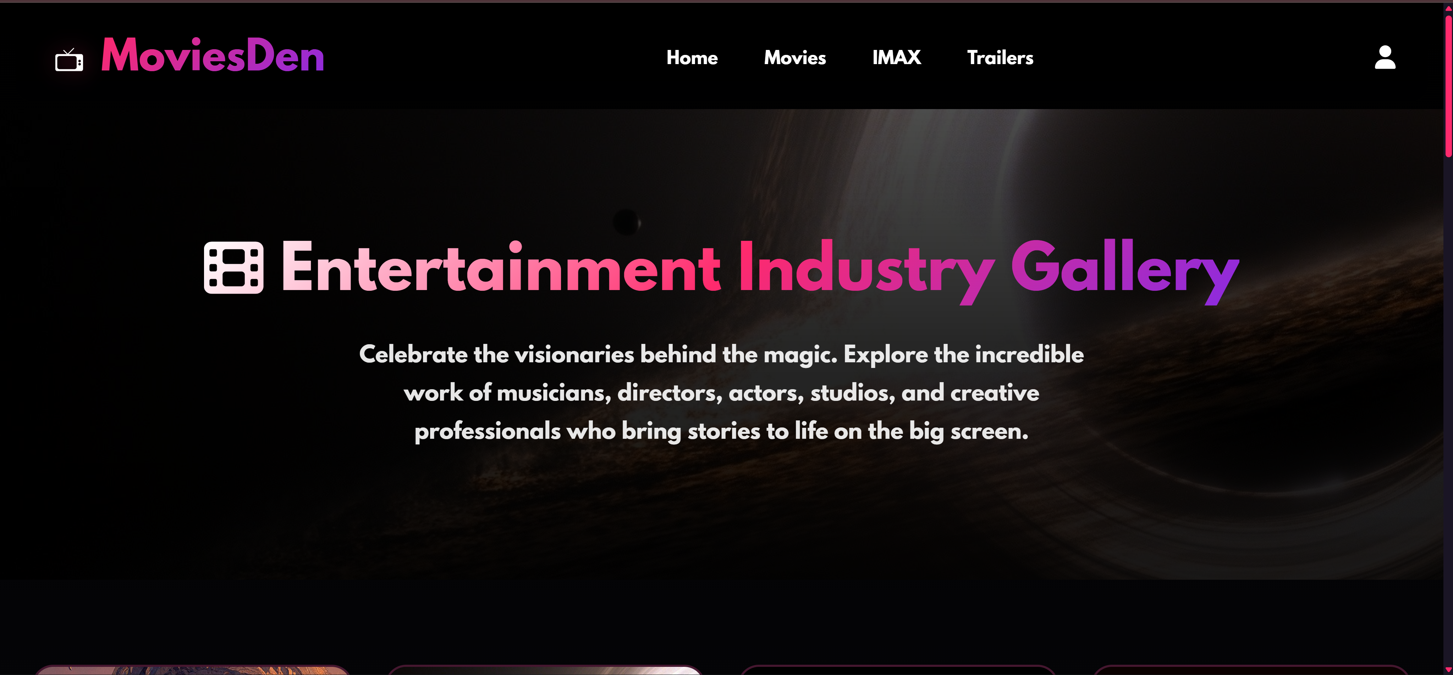

**Trailer(Watch.HTML):**

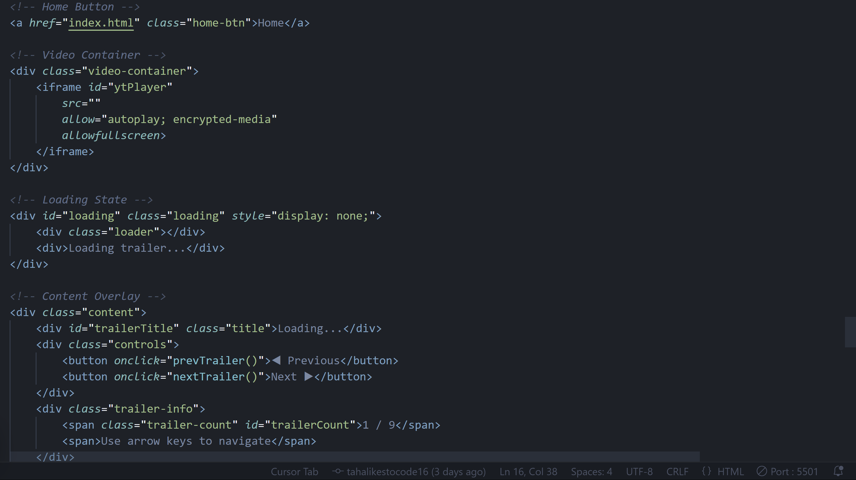

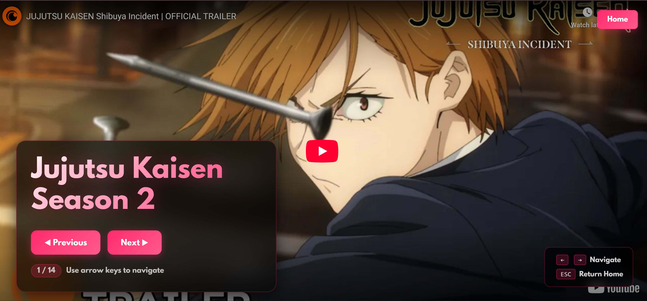

**About(About.HTML):**

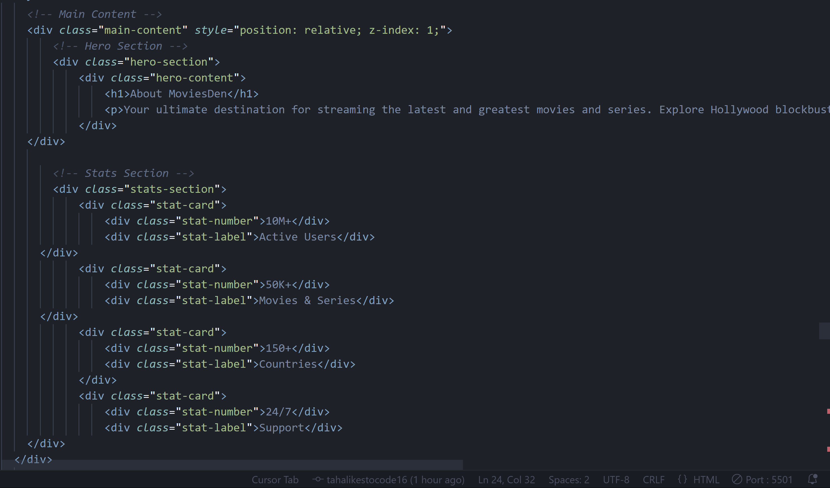

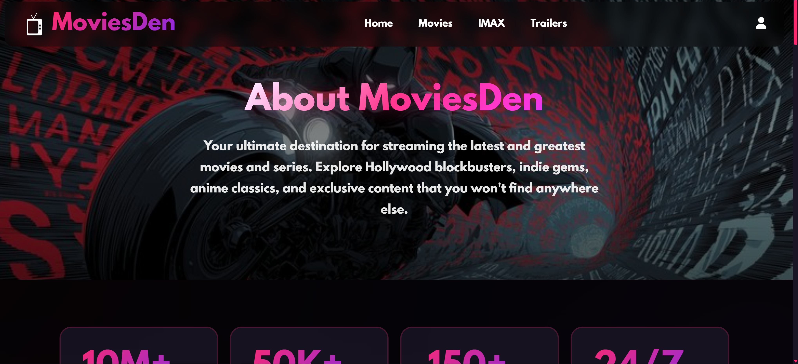

**Contact(Contact (1) (1).HTML):**

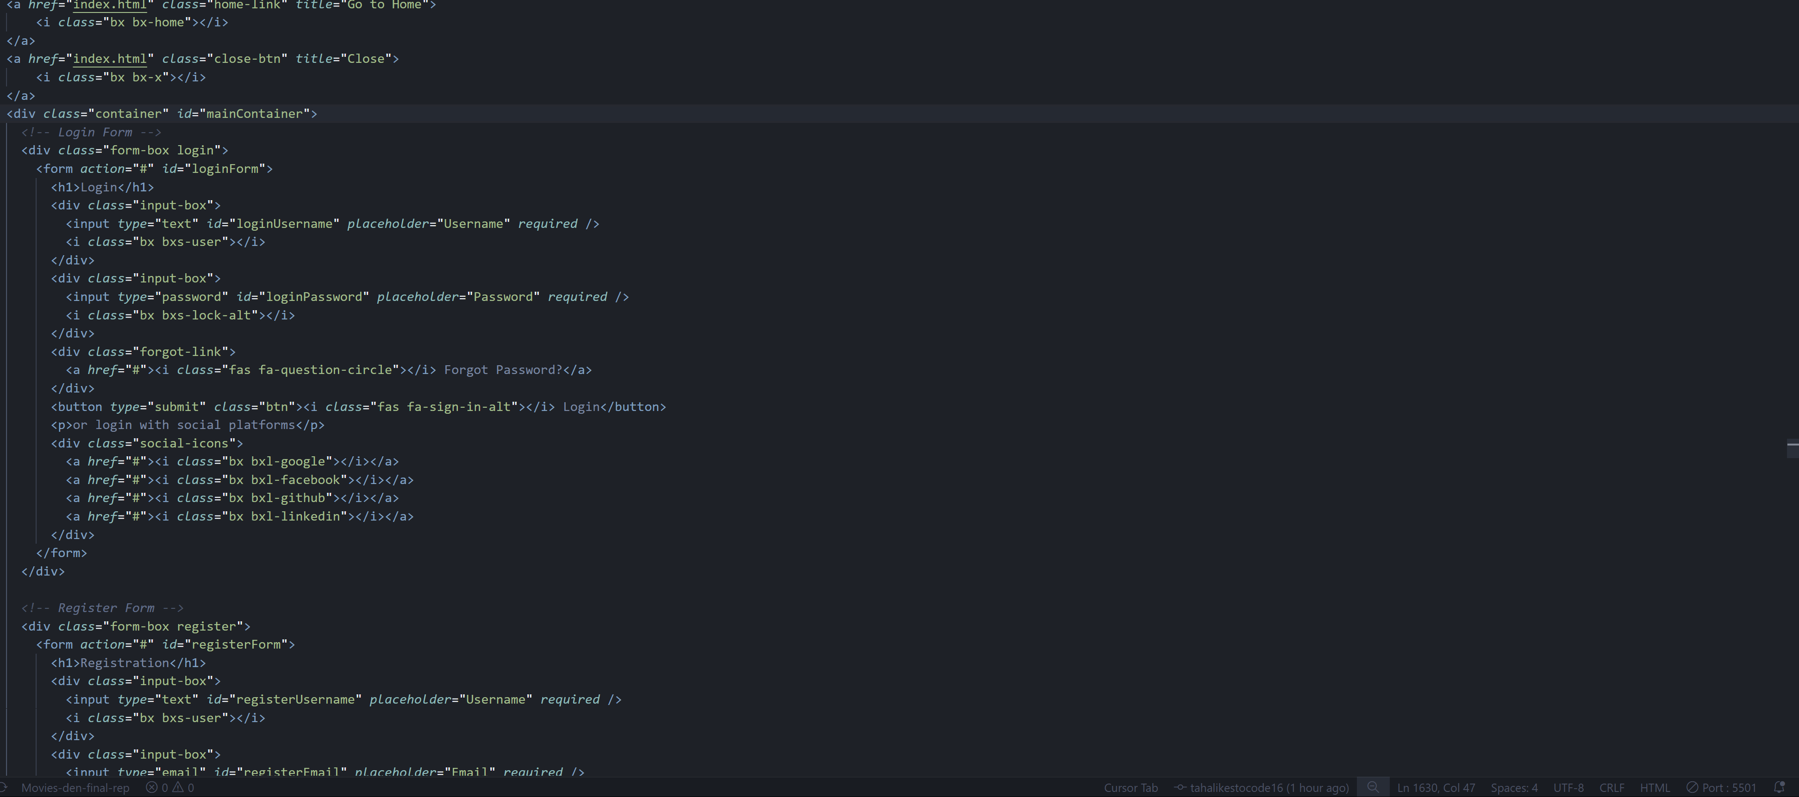

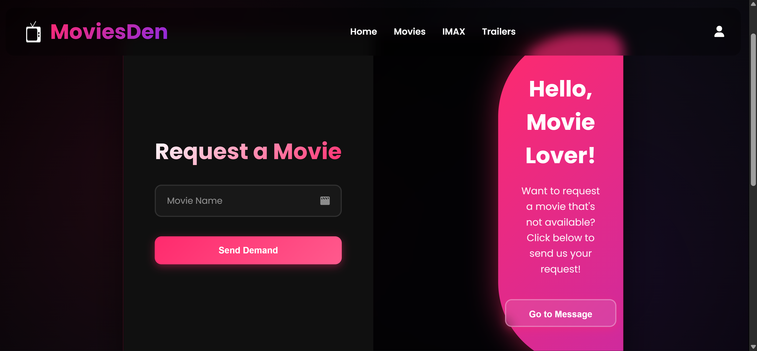

**Signout(signout.HTML):**

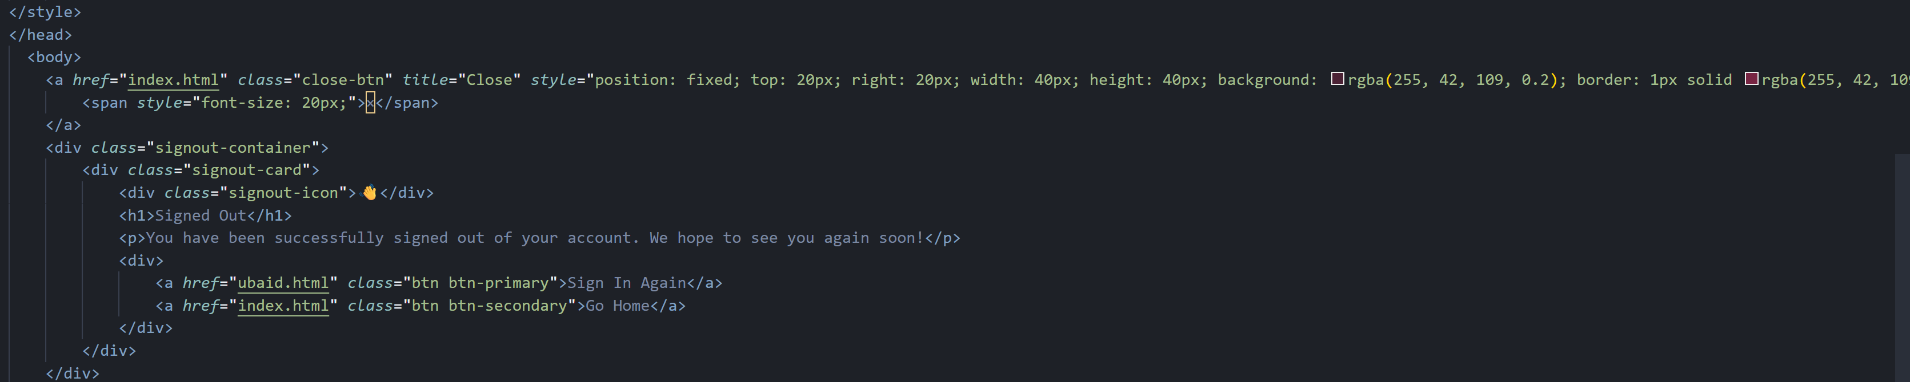

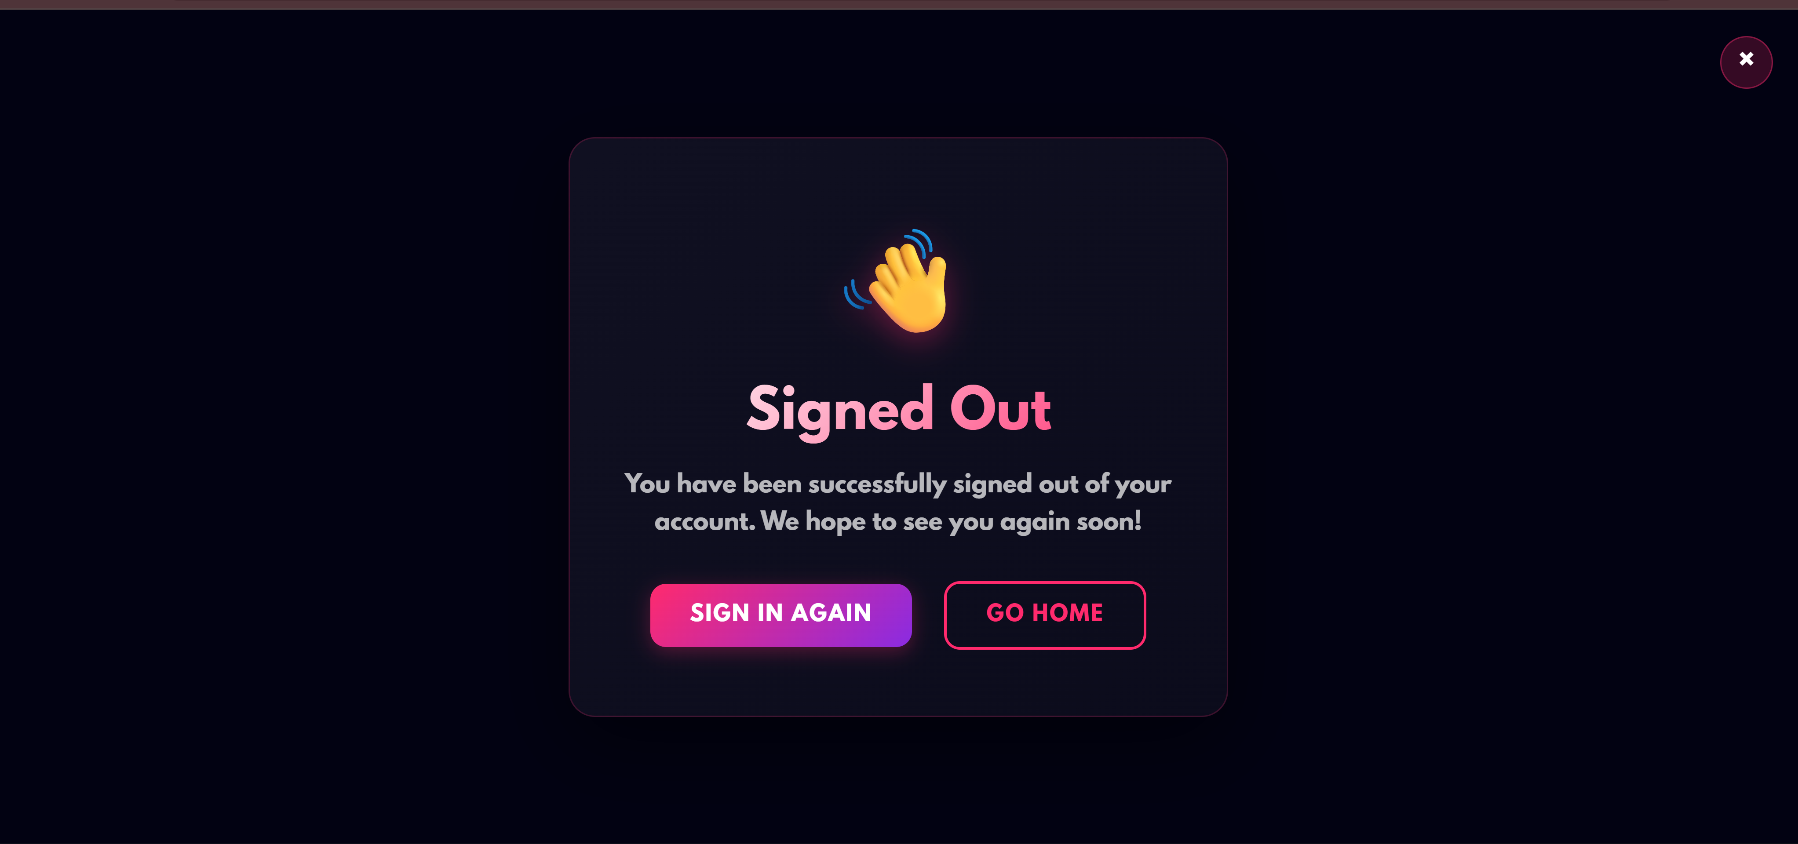

**awards(awards,faq.HTML):**

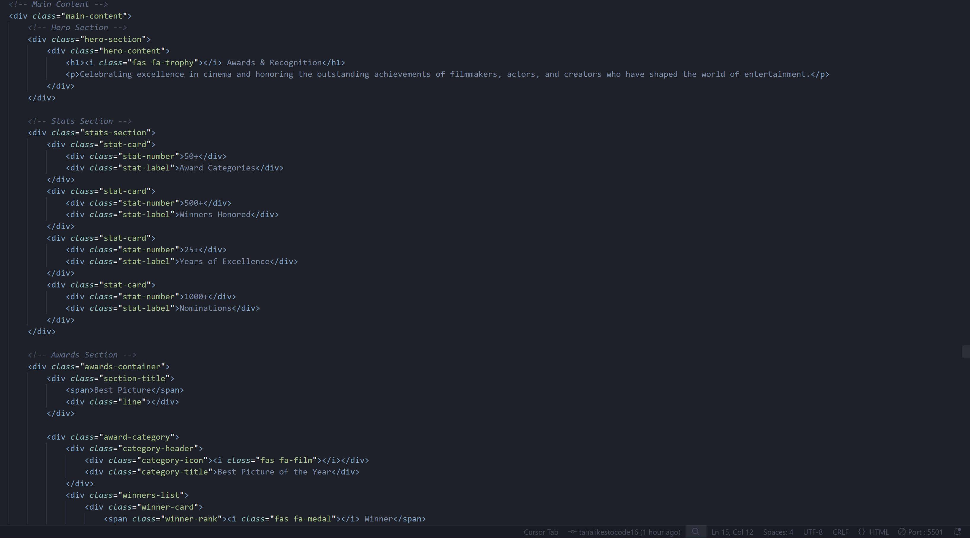

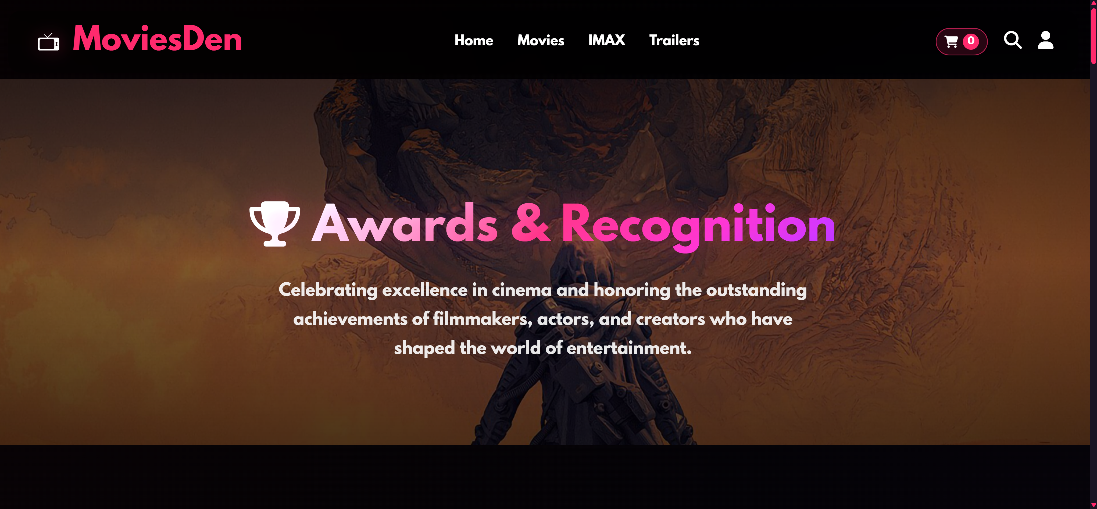

**upcoming(upcoming.HTML):**

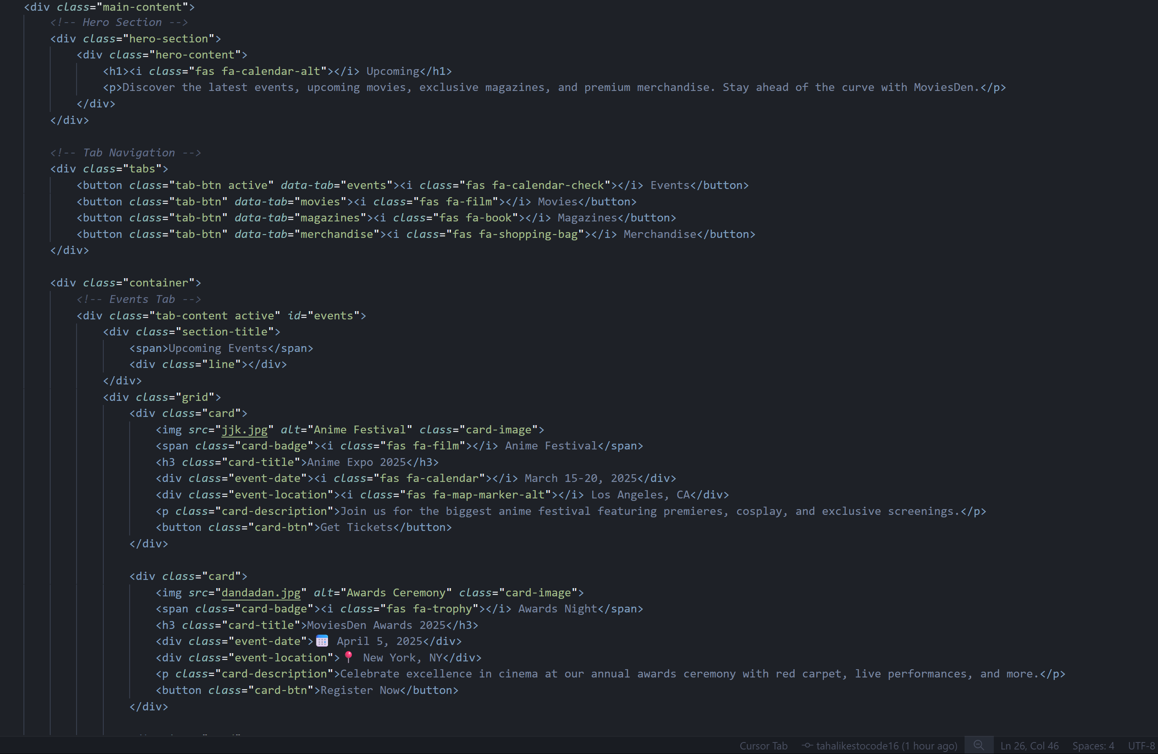

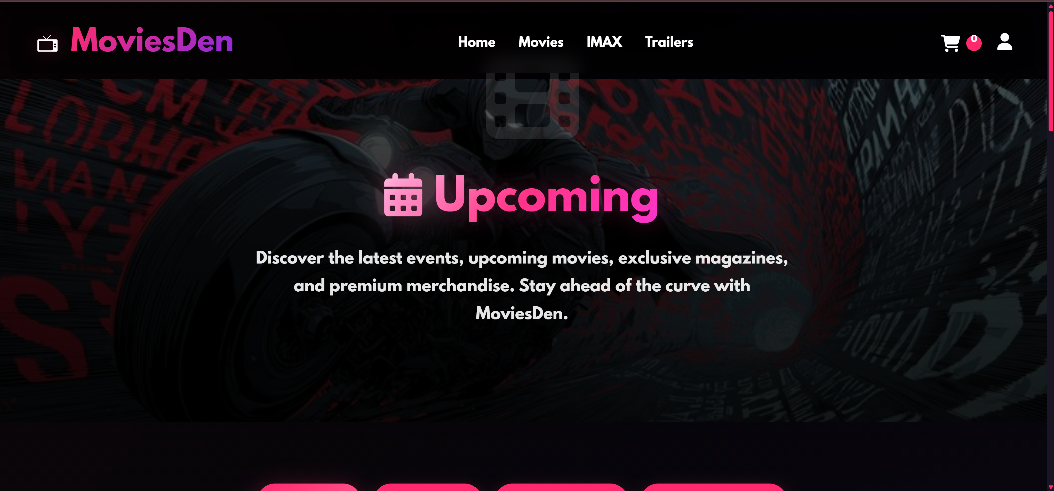

**Footer(everyHtmlFile):**

